ПЛАН-КОНСПЕКТ
УРОКА АНГЛИЙСКОГО ЯЗЫКА С ИСПОЛЬЗОВАНИЕМ СТРУКТУР СИНГАПУРСКОГО МЕТОДА ОБУЧЕНИЯ.
Класс:7
Учитель: Закиева Рамзия Мухаметовна
УМК: Enjoy English-7, 2007 год.Авторы - Биболетова М. З., Трубанева Н.Н.
Вид урока: комбинированный

Тема урока: «School is fun if you are optimistic»
Цели урока: 1.Практические: вспомнить необходимую лексику по теме «Школа»
2.Обучающие
- введение и активизация лексических единиц по теме - --- -формирование навыка выражения своего мнение о школе
2. Развивающие
- расширение кругозора учащихся;
- развитие языковой догадки;
- развитие интереса к языку;
- социокультурное развитие;
3. Воспитательные
– развитие у учащихся чувства гордости за свою школу
-развитие толерантности к одноклассникам и уважения к учителям
- снятие языкового барьера.

оснащение урока:
- классная доска;
- интерактивная доска;
- аудиозапись;
- раздаточный материал.
Ход урока.
1Организационный момент.
1. Приветствие.
- Good morning, my dear friends! How are you today? Are you OK?
- Let’s begin our lesson. At first greet your face partners, then your shoulder partners, our guests and me. - I’m glad to see you. Sit down.

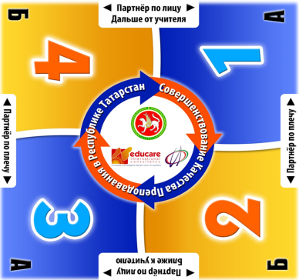

2. Совместное целеполагание.
-Our topic is School is fun if you are optimistic! Let’s start with the words of a Chinese proverb «Teachers open the door, but you must enter by yourself». Will you translate them, they are very wise. Thank you.
-What are we going to do today? We are going to read English, speak about our school, students and teachers and express our opinions about the school.

2. Совершенствование лексических навыков. Использование структуры Джот Тотс. (Jot Thoughts)
-So let’s start. Dear students, on your tables you have cards. Each of us has to take four cards and to write down four words, which associate with the school (for example: lessons, teachers, break, textbook and so on.) Now, let’s start!
-Almaz, would you like to read your words?
-Team number 4 speaker number 2, it’s your turn to read all the words. Excellent, thank you!
3. Совершенствование навыков чтения.
- I am a teacher, and who are you? You are pupils, aren’t you? You go to school now; your parents went to school when they were children. Some people like the school, others don’t. But people of different ages always have something to say about school.
Now I want you to work in groups. Each group is given a short text, in which some grown-up people and schoolchildren are sharing their opinions about school. Which of these opinions belong to grown-up people and children? How did you guess? Share your opinion in your group using Single Round Robin.
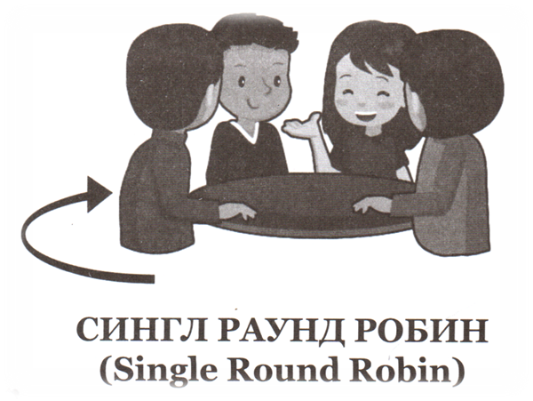
Mike: I don’t like school very much. I have some problems with maths. I’m always nervous when we have a test. I would like not to have any tests. Besides I hate homework. I think that everything is boring at school. School is a waste of time (бесполезная трата времени). I can get information from books, TV and my computer! But I can’t do without my friends. I am glad I see them every day at school.
Mary: our school is not the best, but I like it. It’s big and new. Everything is good. I am good at a lot of subjects. My parents are happy that I get excellent and good marks. So am I. I’ve got three favourite subjects. They are Science, IT and History. Most of my teachers are nice, some are strict but fair.
Jane: I went to the local school, it was an all girls’ school, and we had to wear a uniform. That uniform! I really hated it! We had to wear one of those…you know…little hats. Ooh! We didn’t mix much with (общались с) children from other schools. Oh, and I am also sorry that we never did things like cookery or needlework (вышивание).
William: School? I lived in the country and I went to the little village school. We were all together- boys and girls of all ages. It was like one big, happy family. I never had any exams. My school days were very happy. The teaching was very good and there were lots of after-school activities. I played in the school orchestra. That was very interesting! I am not sorry that I went to my little village school.
4. Чтение с пониманием основного содержания.
- Now let’s speak about school as a building.
Text #1.Our school building is neither large nor small. It has three floors. On the ground floor we have a gymnasium, some classrooms and a dining-room. On the first floor there are many classrooms, a library and a school-hall. There is a sport-ground in the yard.
Text #2.My school is rather new. The building is large. It has four floors. On the first floor there are some classrooms, a cloak-room, a dining-room. On the second floor we have a large school-hall, two gymnasiums and many classrooms. There are four IT rooms on the fourth floor. Here we can work on a computer. We also have a library on this floor.

-Read the texts and say which text is about your school building – the first or the second one? Why do you think so? Share your opinions in your group using Single Round Robin.

5. Физкультминутка.

6. Развитие навыка устной речи. Использование структуры Мих Пэа Шэа
- Now let’s continue our work .I would like you to stand up, move your chairs. Let’s mix! Stand in pairs. Give five each other .Look at the question on the screen. Think it over and start discussing using RELLY ROBIN (or TIMED PAIR SHARE).
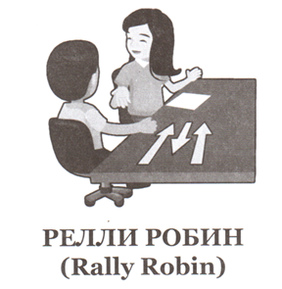

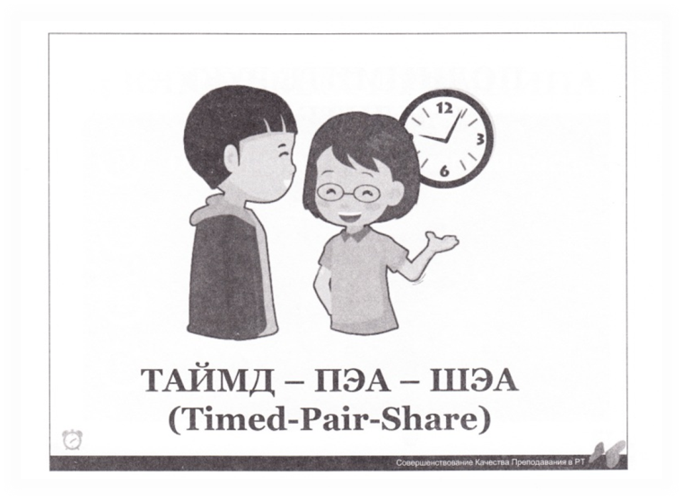

-What is your favourite subject? Why do you like it?
- And can you imagine a school without teachers? Of course we can’t. There are many teachers in our school. They are men and women, young and old, experienced and just the beginners. They are different. What do you think your teachers should have? What kind of teachers would you like to have?
-So what is a school for you?
- Do you like school? Why?

7. Рефлексия.
Teacher: So, boys and girls, what have we done today?
Have you read the texts? ---- Yes, we have.
Have we spoken about teachers and students? -----Yes, we have.
Have we expressed our opinion of school? -----Yes, we have.
So, our tasks are fulfilled.
Thank you for your work.
Write down your home task- ex. 7 p. 92 from your textbook.

8. Итоги урока. Oценки.
I want to finish our lesson with the words of Henry Ford, one of the famous American people.
Чтение и перевод слов Генри Форда: Anyone who stops learning is old, whether at 20 or 80. Anyone who keeps learning stays young.
-Thank you for your work. Your marks are…
9.Билет на выход. Exit ticket.
- Take two cards. On the first write down your wishes to me. On the second write a question or a problem you would like to discuss in the next lesson.

